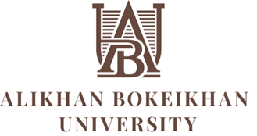

Information letter
International practical seminar
"Psychological competence of a teacher: topical issues of technology of working with students"

Dear colleagues,
"Alikhan Bokeikhan University" would like to invite you to take part in the international practical seminar "Psychological competence of a teacher: current issues of technology for working with students", which will be held on December 6-8, 2022, organized by the Department of International Cooperation of ABU together with the ANO "Institute of Psychology: Education and Human Development" (Barnaul).

Target audience: teachers and psychologists of universities, colleges, teachers and psychologists of schools.

The content of the training:
1. Neuropsychological approach to learning difficulties in students.
2. Psychological and pedagogical conditions management of educational motivation of students.
3. Methods of self-regulation in the professional activity of a teacher, psychologist.

Venue:
Administrative building of Alikhan Bokeikhan University at
11 Mangilik El Street (building behind the tax inspectorate)
The assembly hall is on the 4th floor.

Time of the event:
December 6-8, from 14.30 to 17.30.

Document: Upon completion of the program, all registered participants will be issued a certificate of professional development for 72 hours, indicating the full name, the name of the program.

Program Speaker:
Lyubimova Olga Markovna, PhD, associate Professor. Director of the ANO "Institute of Psychology: Education and Human Development" (Barnaul).
￼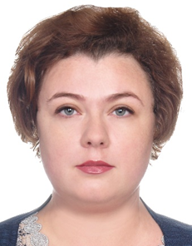
Leading expert of the Altai Territory in the field of clinical psychology, general psychology.
She has numerous awards and letters of thanks from the leaders of the Altai Territory and Barnaul for his contribution to the training of specialists in the field of psychology.
Author of more than 45 scientific papers. Research interests: psychology of consciousness and self-consciousness in norm and pathology; qualitative methods of collecting and analyzing information; verbal and communicative technologies in the work of a psychologist; individual style of activity.

Registration for the program is made until December 3, 2022.
The cost of participation in the seminar program for participants is 5000 tenge.
Payment must be made to the university's account using the following details and the payment receipt must be sent together with the registration form to the email address indicated below.

Payment details:
Educational institution "Alikhan Bokeikhan University"
Bank details:
BIN 980440002042, Kbe 17 RNN 511700061447
IIC KZ 976010261000026178 JSC "Halyk Bank of Kazakhstan"
BIC HSBKKZKX

Applications should be sent to:
oms_abu@mail.ru (address with a lower space)
Applications without a payment receipt are not accepted!!!!!!!
Additional information - number with WhatsApp: + 7 702 113 7735 (only during working hours from 9 to 18.00!) – Zholdyhanova Akbota Serikkhanovna
Application form:
Full name in Russian (according to the certificate – to fill out the certificate):
Place of work:
E-mail:
Contact phone (preferably with WhatsApp)

Attention!
The seminar will be held only in full-time format,
Online participation is not provided!

